|  |  |
| --- | --- |
|  |  |

**Nexus VSSC Sub-ARF Process**

**REVISION HISTORY SUMMARY**

|  |  |  |  |
| --- | --- | --- | --- |
| **Date** | **Version** | **Changed By** | **Revision Summary** |
| 09/24/2013 | 1.0 | David Hernandez/Cindy Norton | Initial release of document |

**Purpose:**

This document is to provide the Business Rules for the VSSC Nexus Sub-ARF Process as well as suggested work processes for VSSC Team.

Sub-ARF Definition:

A Sub-ARF (Associated Consultation Request) is a specific task related to a PID request received from Sales. A single or multiple Sub-ARFs can be associated with a Primary PID. There is no limit to the number of Sub-ARFs that can be created associated with a Primary PID.

VSSC Sub-ARF Process Business Rules:

1. FSSC will transfer PIDs to VSSCs.
2. Sub-ARFs should only be created for the following:
   * If multiple Sub-ARF(s) are needed the VSSC can create from the original PID.
     1. For multiple product trainings;
     2. Multiple customer contacts;
     3. LARs.
3. Closing Sub-ARFs
   * **VSSC-Completing a Sub-ARF**

VSSC will complete the Sub-ARF after contacting and completing work with the Customer. VSSC will ensure that Nexus notes are completed in detail per current process. (See steps to complete a Sub-ARF in the process).

* + **VSSC-Terminating a Sub-ARF**

If the VSSC needs to terminate the Sub-ARF they will complete notes/time-log,terminate the Sub-ARF using ‘Terminate instructions’ below (See steps to terminate a Sub-ARF in the process).

* + 1. The VSSC Agent can choose to terminate the Primary ARF. If the VSSC Agent chooses to take further action they can complete from the primary ARF or if determined appropriate, they can create a new Sub-ARF.

1. Time log entries must be made from CAD Workflow, and must be entered from an ARF with a PID #.

Update Nexus notes and Notepad field as normal.

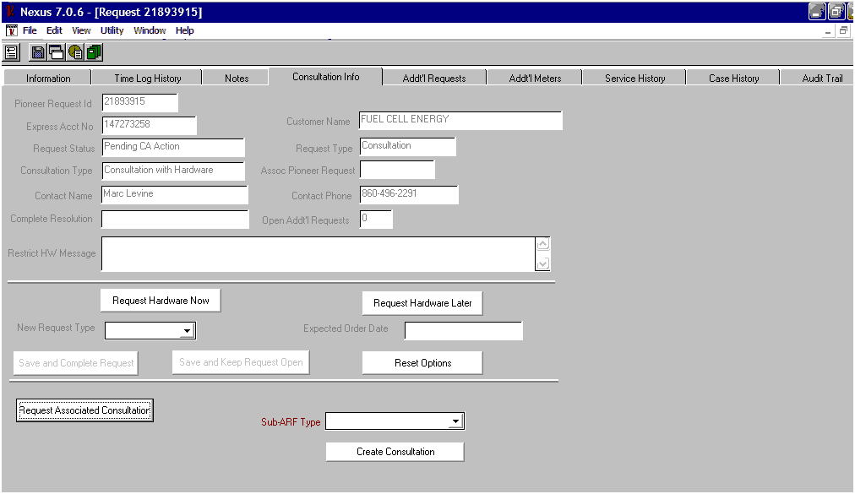

Choose Sub-ARF Type

All Sub-ARFs must be Completed or Terminated before a Primary PID can be Completed or Terminated. In order to determine if all Sub-ARFs have been completed you will need to validate this by viewing the Nexus Summary Screen or Information Tab which will show the “Open Addt’l Requests” field indicates 0. *See screen shot below.*

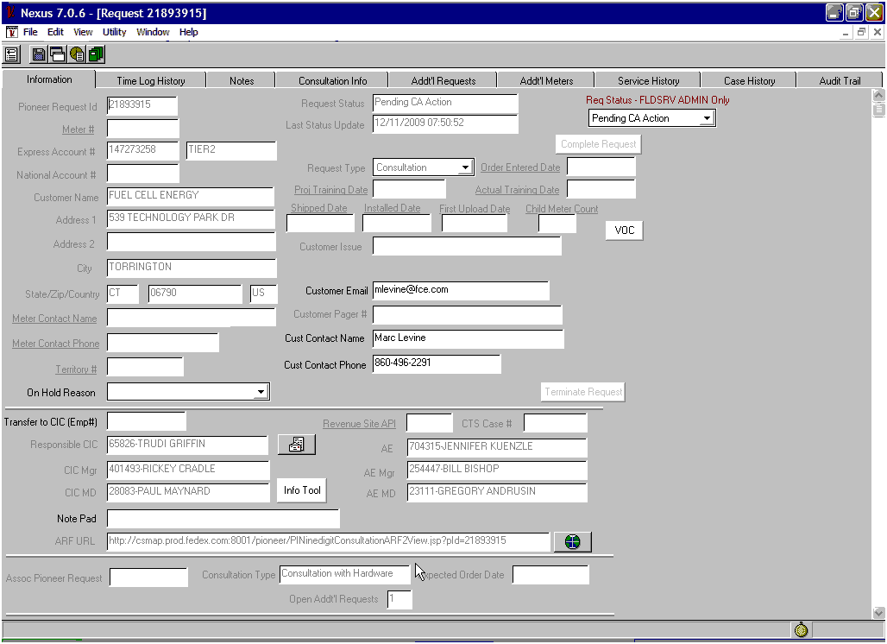

To view the Sub-ARF information, check the Additional Request Tab to see if Sub-ARFs Terminated or Completed.

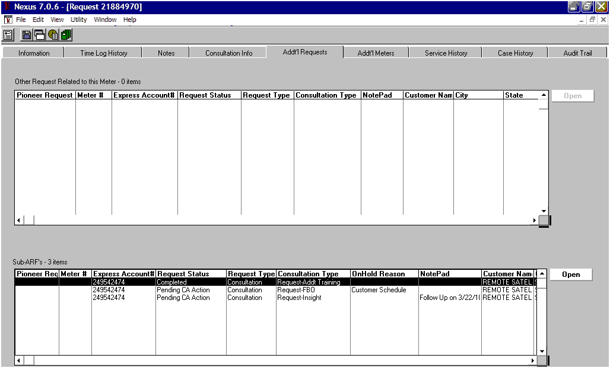

Each Sub-ARF request can be opened to view Nexus Notes for details.

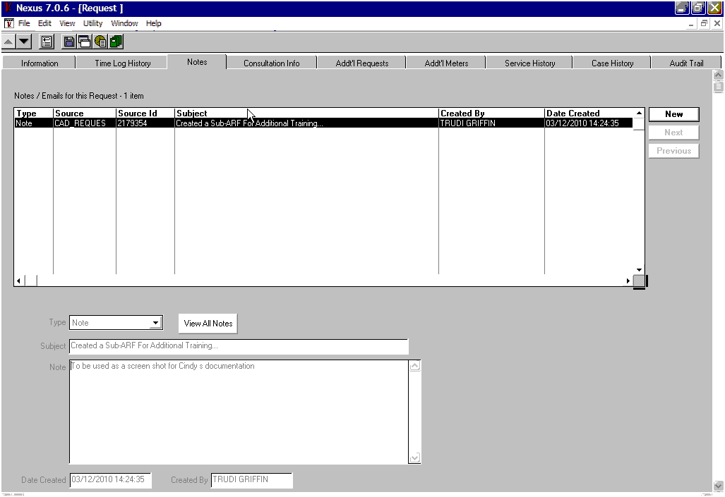

VSSC can use the ‘Notepad’ field that was added to the **CAD Workflow** screen for

sorting or organizational purposes. This field will store 70 characters.

